Computer Engineering Department
King Mongkut’s University of Technology Thonburi

CPE 241 Database
Individual Lab #04 Add a new line-item UI Form. Add Reports.

Date: Check Individual 04 assessment activities on LEB2
Introduction
In Individual 03, you successfully enhanced the Invoice Management System by adding salesperson support and implementing line-level discount and invoice-level calculation logic. This allows you to understand how business rules and computed fields are integrated across the front-end, back-end, and database layers.
In this lab, you will further extend the existing application by introducing a new module called Receipt, which supports customer payments for invoices. The purpose of this exercise is to help you understand how financial transactions such as partial payments and outstanding balance tracking must be accurately handled and synchronized across the entire system.
You will expand the system by adding receipt header and line-item structures, integrating them with existing invoice data, and enforcing business rules such as filtering unpaid invoices and correctly computing received and remaining amounts. This activity will demonstrate how transactional relationships between receipts and invoices are maintained and propagated through backend services and user interface components.
Objectives
In this lab, you will upgrade your existing Individual 03: Invoice system; new receipt transaction, related queries, printing, and reports. This lab focuses on:
- partial payment handling
- outstanding balance tracking,
- correct receipt allocation to invoices.
Important deployment rule
This lab is an upgrade. Do not recreate the whole database. Apply your schema and database object changes using a delta deployment script (e.g., invoice_lab4_delta.sql).

Functional Requirements
- Add Receipt to the application menu
  - Add Receipt to the main menu.
  - When the user opens Receipt from the menu, it must start with the Receipt list view.
  - Receipt must support both list view and form view.
  - The form view must support creating, editing, viewing, and printing a receipt.
The Form View
The following is a UI view of the Receipt Form View. You should implement it using a UI with similar look and feel to the Invoice Form View used in Previous Labs.
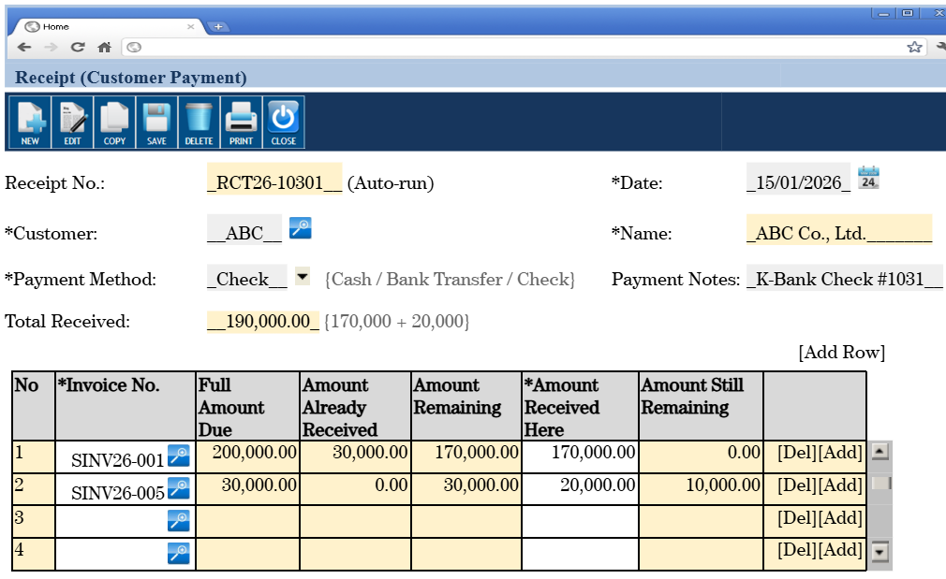
- Receipt header fields
  - Receipt No. with running format: RCT + YY + "-" + 5-digit running number. Example: RCT26-10301.
  - Date.
  - Customer code with LoV button. The LoV is similar to the customer LoV button in the Invoice form.
  - Customer name shown automatically from selected customer information and cannot be edited.
  - Payment method. Allowed values: cash, bank transfer, check.
  - Payment notes as free text.
  - Total received. This must be computed as the sum of line item “Amount Received Here”.

- Receipt line-item fields
  - Invoice No. with LoV button.
  - The Invoice LoV must list only unpaid invoices of the customer selected in the receipt header.
  - Show Full Amount Due.
  - Show Amount Already Received, computed from all receipts for that invoice, but not counting the current receipt number.
  - Show Amount Remaining = Full Amount Due - Amount Already Received.
  - Editable Amount Received Here. Default value should be Amount Remaining.
  - Show Amount Still Remaining = Amount Remain - Amount Received Here.
- Receipt printing
  - Add capability to print a receipt, similar in spirit to invoice printing.
  - The printed receipt should clearly show the receipt header data and the list of invoice payments received in that receipt.
Business Rules and Validation
- Customer-driven invoice selection
  - The receipt header customer must be selected first before the user can choose invoices in receipt line items. Without a customer selected, no invoices should appear in the Invoice No LoV.
  - Invoice LoV must show only invoices belonging to the selected customer.
  - Invoice LoV must exclude fully paid invoices.
- Amount logic
  - Amount Already Received must not count the current receipt number, even when the user edits and saves the receipt.
  - Amount Received Here must not be negative.
  - Amount Received Here should normally not exceed Amount Remaining.
  - Total Received in the header must always equal the sum of line-item Amount Received Here.
- Required test case to verify a common bug
  - Suppose invoice INV26-31127 has Amount Due = 1,000 and Amount Already Received = 200 before this receipt is created.
  - The customer now pays the remaining 800 using a new receipt, for example RCT26-10032.
  - Before saving and after saving, the Amount Already Received shown in that receipt line should still be 200 because this column must exclude the current receipt number.
  - A common bug is for the system to show 1,000 instead of 200 after save because the Amount Already Received accidentally includes the payment from the current receipt. Your design and testing must avoid this bug.
Database Requirements
- New transaction tables
  - Create the required receipt header and receipt line-item database structures, using a naming style consistent with your existing lab application.
  - Use proper primary keys and foreign keys.
- Required database view
  - Create a view named invoice_received with the following shape: invoice_received_view (customer_id, invoice_id, invoice_no, amount_due, amount_received, amount_remain)
  - This view should support the receipt screen logic and the reporting requirements.
- Deployment script
  - All database changes must be included in a delta deployment script, for example invoice_lab4_delta.sql.
  - The script should include all new tables, constraints, indexes if needed, view definitions, and any seed/reference data if applicable.
Reports to Add
- Report 1: List of receipts
  - Provide a report with filters: date start, date end, customer code.
  - All filters are optional where Null means “select all” in each filter.
  - The report output must show: receipt no., date, customer code, payment method, payment notes, customer name, total amount received.
- Report 2: List of invoices and receipt information
  - Provide a report with optional filters: invoice start date, invoice end date, customer code.
  - The report output must show: invoice no., invoice date, customer code, customer name, invoice amount due, invoice amount received, invoice amount still remaining, receipt no., receipt date, received amount for this invoice. Note that the last 3 fields are a list of receipts for this invoice.

Report:
Invoice No. | Date | Customer Code | Customer Name | Invoice Amount Due | Invoice Amount Received | Invoice Amount Still Remaining | Receipt No. | Receipt Date | Receipt Amount
INV26-111 | 1/1/26 | ABC | ABC Co. | 1,000 | 1,000 | 0 | RCT26-010 | 12/01/26 | 300
 |  |  |  |  |  |  | RCT26-021 | 13/02/26 | 700
INV26-112 | 3/1/26 | XYZ | XYZ Co. | 3,000 | 0 | 3,000
INV26-113 | 7/1/26 | ABC | ABC Co. | 2,000 | 1,500 | 500 | RCT26-021 | 13/02/26 | 1,000
 |  |  |  |  |  |  | RCT26-024 | 15/02/26 | 500
INV26-114 | 7/1/26 | Charoen | Charoen Co. | 1,500 | 1,500 | 0 | RCT26-027 | 17/02/26 | 1,500

API and UI Changes
- APIs
  - Add or modify backend APIs as needed for Receipt header, Receipt line items, invoice LoV filtering, printing, and the two reports.
- UI screens
  - Add Receipt list view.
  - Add Receipt form view.
  - Add Invoice LoV for receipt line items.
  - Add printing UI action for receipts.
  - Add UI pages/forms for the two reports, including their filter inputs.

Deliverables
Submit one PDF that clearly includes all required evidence.
- Do not submit scattered screenshots without labels. Organize the PDF in the same sequence as the deliverables below.
- Every screenshot should be readable and should show enough of the screen to verify the requirement.
- Do not submit more than what is requested.

- Receipt list view and form view. Show that Receipt is available from the menu, opens to list view with at least 5 records.
- Receipt form view. Show 2-3 receipt form views already saved with at least 2 invoices per receipt and with enough data to show that the line-item logic especially that related to “amount remaining” works correctly.
- Receipt line-item Invoice LoV correctly filters to unpaid invoices for the selected customer only. Include a screenshot that proves this.
- Printed receipt screenshot for 1 receipt (choose a nice demo receipt with 2–3-line items).
- Show Report 1 (List of receipts) with filter inputs and report output is working.
- Report 2 (List of invoices and receipt information) with filter input and report output is working.
- Include your source code only for the frontend code and APIs related to receipt form and report. Also, include the source code for the invoice_lab4_delta.sql script. Points will be deducted if you do not submit this.
- Do not submit more than is requested.

Final Submission
- Submit a PDF file and ensure it is named appropriately (e.g., IND04_YourStudentID.pdf) then submit the report on LEB2 before the deadline.
- Upload the PDF report to the Assessment Activities section for Individual04 on LEB2.

